Exercise 4

1. Develop required HTML and CSS to render the following user interface:

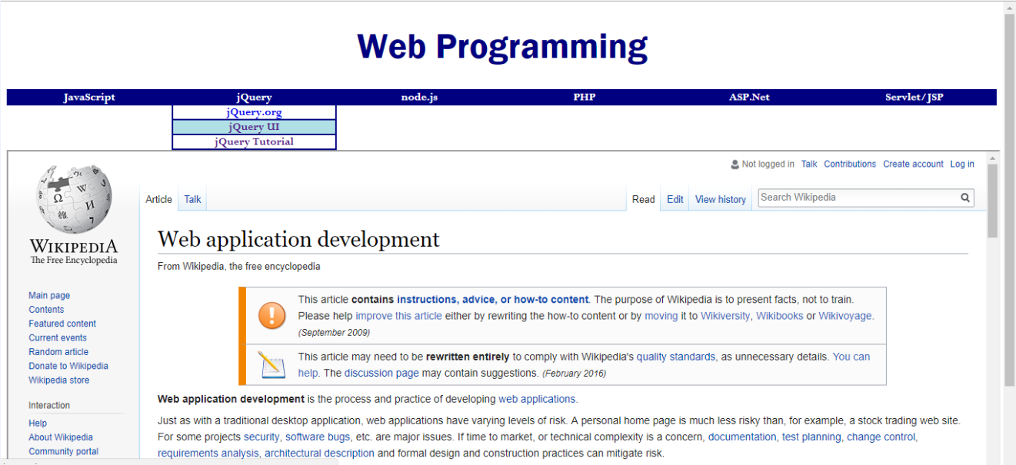

1. Please **modify Fig. 4.17 (all features should be kept)** to develop the drop-down menu includes the following title and items:

JavaScript

* + - * W3Schools: <http://www.w3schools.com/js/default.asp>
      * MDN: <https://developer.mozilla.org/zh-TW/docs/Web/JavaScript>
      * JSON: <http://www.json.org>

jQuery

* + - * jQuery.org: <http://jquery.org/>
      * jQuery UI: <http://jqueryui.com/>
      * jQuery Tutorial: <http://jsgears.com/thread-63-1-1.html>

node.js

PHP

ASP.Net

Servlet/JSP

* + - * Tutorial: <http://www.journaldev.com/2114/servlet-jsp-tutorial>

Other requirements:

* + - * Each item can be linked to the specified URL **in a new window**.
      * Please set the font to Perpetua.
      * Please change the theme color from RoyalBlue to Navy. (把原本的RoyalBlue藍色加深為Navy)
      * The width of each item is about 16.666% of the screen width.

1. Please add an <h1> heading, “Web Programming”, in the top.
   * Please set the font to Franklin Gothic.
   * Please set the text color to Navy.
2. Please embed your HTML of the wiki page of “web application development” as the above figure using <iframe>.
   * Width is set to 100%
   * Height is set to 400 px
3. Please let the page to change the presentation of its menu for a smaller screen (width is less than or equal to **600px**), as follows:

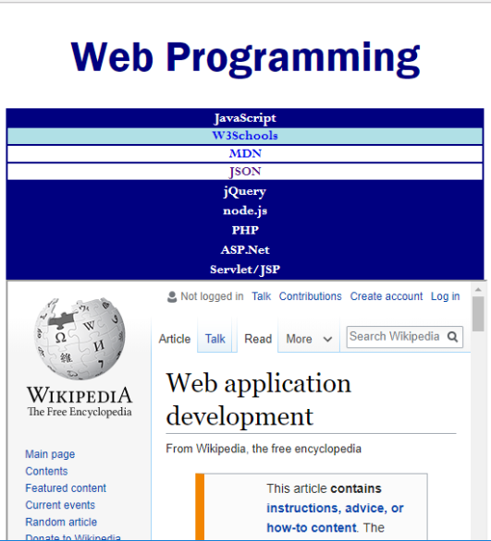

**Hints:**

* You may need to know how to set layout of six <div>: <https://www.w3schools.com/cssref/pr_class_float.asp>
* Please refer to <https://www.w3schools.com/css/css3_box-sizing.asp> to study how to control the size of each <nav>. (每個nav需要改計算size的模式才能以16.66%平均分配)
* Please refer to <http://www.w3schools.com/tags/tag_iframe.asp> to study “iframe”.
* Please refer to <https://www.w3schools.com/css/css_rwd_viewport.asp> to study how to set up “viewport”. (作為自適應網頁-RWD的第一步)
* Please refer to <https://www.w3schools.com/css/css_rwd_mediaqueries.asp> to study how to use “media query” to change the presentation in a smaller screen.
  + You should change the width of <nav>

1. Develop a JavaScript program that displays a "square" that is composed of images of assigned or random Pokemons based on the given side length. The expected user interfaces are as follows:

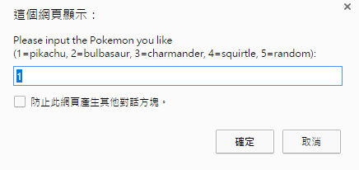

Show the question: "Please input the Pokemon you like (1=pikachu, 2=bulbasaur, 3=charmander, 4=squirtle, 5=random):" with default value 1.

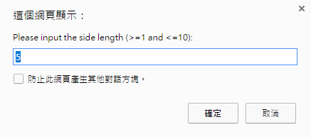

Show the question: "Please input the side length (>=1 and <=10):" with default value 5.

If the user chooses 1~4, the square is composed of repeated images of the assigned Pokemon:

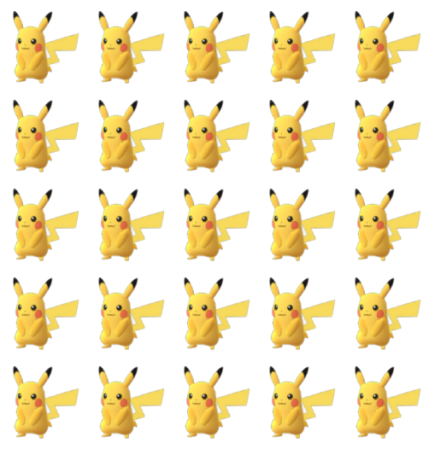

If the user chooses 5 (i.e. random), the square is composed of random images of Pokemons.

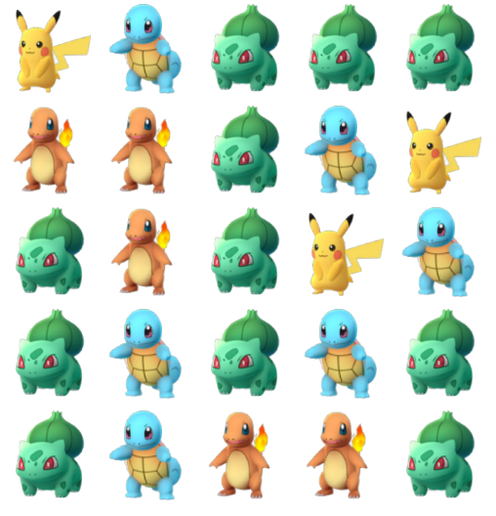

If the user inputs a wrong data, please show an alarm message "Wrong input! Please press [F5] to reload the page!" in a popup window.

(Wrong data: not 1~5 for the first question, and not 1~10 for the second question)

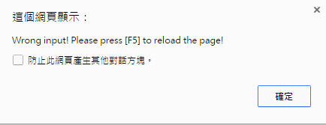

The file names of Pokemon images are pikachu.png, bulbasaur.png, charmander.png, and squirtle.png.

Hint:

* Use *Math.random()* and *Math.floor()* to generate random numbers.

<https://www.w3schools.com/jsref/jsref_random.asp>

<https://www.w3schools.com/jsref/jsref_floor.asp>